**A MINI PROJECT REPORT**

**ON**

**“Crypto Price Tracker”**

Submitted in the partial fulfillment of the requirements for

The degree of

**BACHELOR of Engineering IN Computer Engineering**

**By**

1) Shubham arutwar - 02

2) Zeeshan Ansari - 27

3) Kanchan Mengune - 52

4) Prajwal ruke - 73

**UNDER THE GUIDANCE OF**

**Prof. Shatabdi M. Bhalerao**



Department of Computer Engineering  
Saraswati College of Engineering, Kharghar, Navi Mumbai  
University of Mumbai  
2021-22

**Saraswati College of Engineering, Kharghar**

**Vision:**

To be universally accepted as autonomous center of learning in Engineering Education and Research.

**Mission:**

* To educate students to become responsible and quality technocrats to fulfil society and industry needs.
* To nurture student’s creativity and skills for taking up challenges in all facets of life.

**_______________________________________________**

**Department of Computer Engineering**

**Vision:**

To be among renowned institution in Computer Engineering Education and Research by developing globally competent graduates.

**Mission:**

* To produce quality Engineering graduates by imparting quality training, hands on experience and value education.
* To pursue research and new technologies in Computer Engineering and across interdisciplinary areas that extends the scope of Computer Engineering and benefit humanity.
* To provide stimulating learning ambience to enhance innovative ideas, problem solving ability, leadership qualities, team-spirit and ethical responsibilities.



**DEPARTMENT OF COMPUTER ENGINEERING**

**PROGRAM EDUCATIONAL OBJECTIVE’S**

1. To embed a strong foundation of Computer Engineering fundamentals to identify, solve, analyze and design real time engineering problems as a professional or entrepreneur for the benefit of society.
2. To motivate and prepare students for lifelong learning & research to manifest global competitiveness.
3. To equip students with communication, teamwork and leadership skills to accept challenges in all the facets of life ethically.



**DEPARTMENT OF COMPUTER ENGINEERING**

**PROGRAM OUTCOMES**

1. Apply the knowledge of Mathematics, Science and Engineering Fundamentals to solve complex Computer Engineering Problems.
2. Identify, formulate and analyze Computer Engineering Problems and derive conclusion using First Principle of Mathematics, Engineering Science and Computer Science.
3. Investigate Complex Computer Engineering problems to find appropriate solution leading to valid conclusion.
4. Design a software System, components, Process to meet specified needs with appropriate attention to health and Safety Standards, Environmental and Societal Considerations.
5. Create, select and apply appropriate techniques, resources and advance Engineering software to analyze tools and design for Computer Engineering Problems.
6. Understand the Impact of Computer Engineering solution on society and environment for Sustainable development.
7. Understand Societal, health, Safety, cultural, Legal issues and Responsibilities relevant to Engineering Profession.
8. Apply Professional ethics, accountability and equity in Engineering Profession.
9. Work Effectively as a member and leader in multidisciplinary team for a common goal.
10. Communicate effectively within a Profession and Society at large.
11. Appropriately incorporate principles of Management and Finance in one’s own Work.
12. Identify educational needs and engage in lifelong learning in a Changing World of Technology.



**DEPARTMENT OF COMPUTER ENGINEERING**

**PROGRAMME SPECIFIC OUTCOME**

1. Formulate and analyze complex engineering problems in computer engineering (Networking/Big data/ Intelligent Systems/Cloud Computing/Real time systems).
2. Plan and develop efficient, reliable, secure and customized application software using cost effective emerging software tools ethically.



**(Approved by AICTE, recg. By Maharashtra Govt. DTE ,Affiliated to Mumbai University)**

**PLOT NO. 46/46A, SECTOR NO 5, BEHIND MSEB SUBSTATION, KHARGHAR, NAVI MUMBAI-410210**

**Tel. : 022-27743706 to 11 * Fax : 022-27743712 * Website: www.sce.edu.in**

**CERTIFICATE**

*This is to certify that the requirements for the mini project report entitled ”****Crypto Price Tracker****” have been successfully completed by the following students:*

Roll numbers Name

02 SHUBHAM ARUTWAR

27 ZEESHAN ANSARI

52 KANCHAN MENGUNE

73 PRAJWAL RUKE

In partial fulfillment of Sem –IV , **Bachelor of Engineering of Mumbai University in Computer Engineering** of Saraswati college of Engineering , Kharghar during the academic year 2021-22.

**Internal Guide**  **External Examiner**

Prof. Shatabdi M Bhalerao

**Mini Project Co-ordinator**  **Head of Department**

Dr. Anjali DadhichProf. Sujata Bhairnallykar

**DECLARATION**

I declare that this written submission represents my ideas in my own words and where others ideas or words have been included. I have adequately cited and referenced the original sources. I also declare that I have adhered to all principles of academic honesty and integrity and have not misrepresented or fabricated or falsified any idea/data/fact/source in my submission. I understand that any violation of the above will be cause for disciplinary action by the Institute and can also evoke penal action from the sources which have thus not been properly cited or from whom proper permission has not been taken when needed.

1. SHUBHAM ARUTWAR – 02
2. ZEESHAN ANSARI – 27
3. KANCHAN MENGUNE – 52
4. PRAJWAL RUKE - 73

Date: 04/05/2022

**ACKNOWLEDGEMENT**

After the completion of this work, words are not enough to express feelings about all those who helped us to reach goal.

It’s a great pleasure and moment of immense satisfaction for us to express my profound gratitude to **Mini Project Guide**, **Prof. Shatabdi M Bhalerao**, whose constant encouragement enabled us to work enthusiastically. His perpetual motivation, patience and excellent expertise in discussion during progress of the project work have benefited us to an extent, which is beyond expression.

We would also like to give our sincere thanks to **Prof. Sujata Bhairnallykar, Head of Department**, and **Dr. Anjali Dadhich, Mini Project co-coordinator** from Department of Computer Engineering, Saraswati college of Engineering, Kharghar, Navi Mumbai, for their guidance, encouragement and support during a project.

I am thankful to **Dr. Manjusha Deshmukh, Principal,** Saraswati College of Engineering, Kharghar, Navi Mumbai for providing an outstanding academic environment, also for providing the adequate facilities.

Last but not the least we would also like to thank all the staffs of Saraswati college of Engineering (Computer Engineering Department) for their valuable guidance with their interest and valuable suggestions brightened us.

1. SHUBHAM ARUTWAR - 02

2. ZEESHAN ANSARI – 27

3. KANCHAN MENGUNE – 52

4. PRAJWAL RUKE - 73

**Abstract**

A cryptocurrency is a form of digital asset based on a network that is distributed across a large number of computers. The advantages include cheaper and faster money transfers and decentralized systems. Disadvantages include their price volatility, high energy consumption for mining activities.

Due to this high volatility of cryptocurrencies its difficult to keep track of their prices. This project is made to help user to keep track of their cryptocurrencies market value by providing real time data in Indian rupee.

This project is made by using React Native for building application and CoinGecko API to retrieve the data about cryptocurrencies market value.

**Table of Contents**

|  |  |
| --- | --- |
|  |  |
| **1. Introduction ………………………………………………………………………………….** | **2** |
| **1.1 Objective and problem statement ……………………………...................** | **2** |
| **2. Methodology ……………………………………………………………….......................** | **3** |
| **2.1 Design Details…….………………………………………………………….............** | **3** |
| **2.2 Flowchart…….………………………………………………………………..............** | **5** |
| **2.3 Hardware and Software requirements……………………………………** | **6** |
| **2.4 External Libraries……………………………..……………………………...........** | **7** |
| **2.5 API configuration..……………………………..……………………………..........** | **9** |
| **3. Implementation and Results ………………………………………………………** | **11** |
| **3.1. Implementation ....………………………………………………….....................** | **11** |
| **3.2. Results ...……………………………………………………………….......................** | **15** |
| **4.Conclusion and Future Scope…………………………………………………………** | **16** |
| **5. References………………………………………………………………...........................** | **17** |

**CHAPTER 1**

# INTRODUCTON

## 1.2 OBJECTIVE AND PROBLEM STATEMENT

The goal of the project is to develop an application which helps to track current market value of Crypto currency in real time.

The main objective of this application can be defined as follows:

1. To inform user about current price of the crypto currency in INR.

2. To provide price chart of that crypto currency of past 7 days for better understanding of market conditions.

3. Making monitoring multiple crypto currencies at once easy.

4. To make the applications UI user friendly and appealing to use.

**CHAPTER 2**

# METHODOLOGY

## 2.1 Design Details

To design this project’s front end prototype we are using Figma. Figma is a vector graphics editor and primarily web-based prototyping tool. Figma is a powerful design tool that helps you to create prototype of websites, applications, logos.

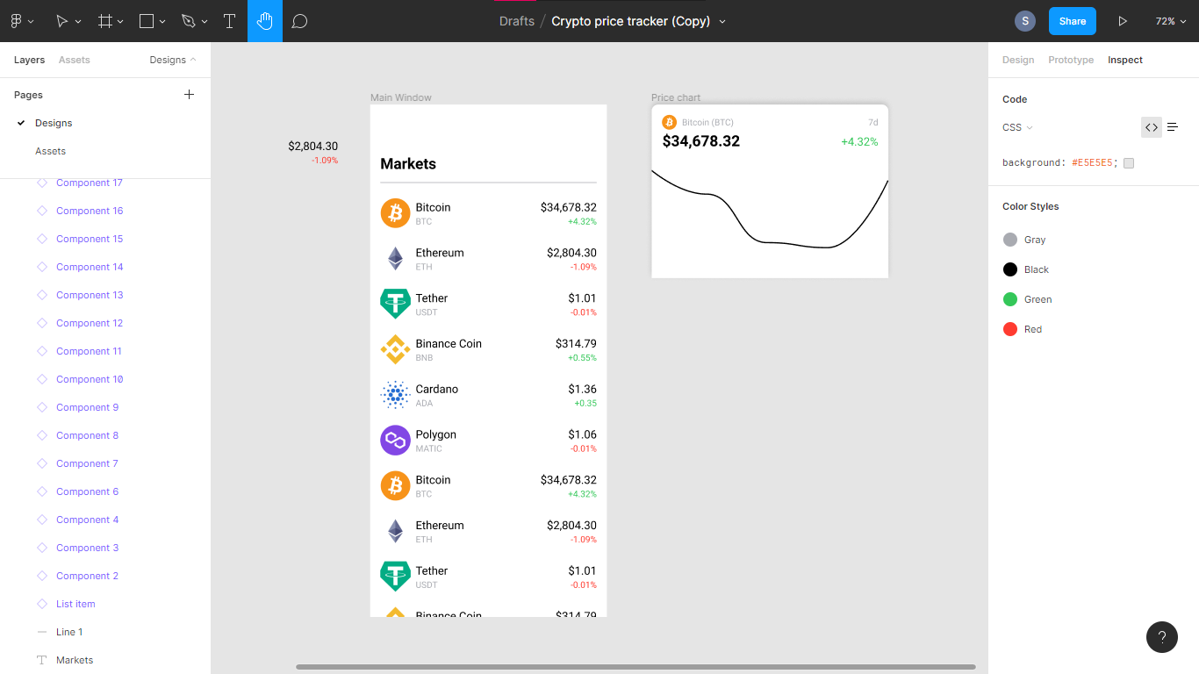

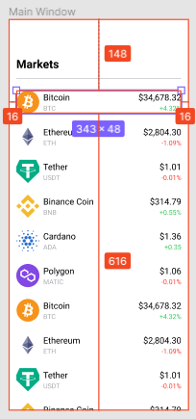 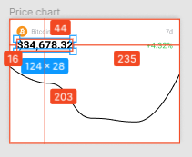

This tool helps us to know exactly how much padding, margin, spacing should be left between elements and makes it verry easy to style the frontend according to needs and get the desiered output.

## 2.2 Flowchart:

**Fig 2.1.1**

## 2.3 HARDWARE AND SOFTWARE REQUIREMENTS

**2.3.1 HARDWARE REQUIREMENTS**

1. RAM: 4 GB
2. Storage: 16 GB
3. Processor: any ARM based dual core processor or above

**2.3.2 SOFTWARE REQUIREMENTS**

1. Android 9 or above Operating System
2. Expo Go application

**2.4 External Libraries**

**2.4.1 Flatlist:**

Extended version of react native flat list with many built in function such as search, pull to refresh, no data available message if empty row .

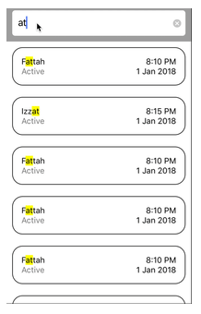

**2.4.2 Bottom Sheet:**

Overlay Modal that displays content from the bottom of the screen.

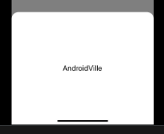

**2.4.3 React native animated charts:**

The main assumptions of the library were to create smooth transitions between subsequent data sets.

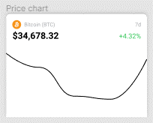

**2.4.4 Axios:**

Axios is a JavaScript library used to make HTTP requests and it supports the Promise API that is native to JS. You can make any HTTP calls using Axios in React Native. Axios provides you the facility to call GET, POST, PUT, PATCH, and DELETE requests.

**API configuration:**

In order to get the data response from API we need to set it up.

We are using CoinGecko API here which provide various different type of information about cryptocurrency,

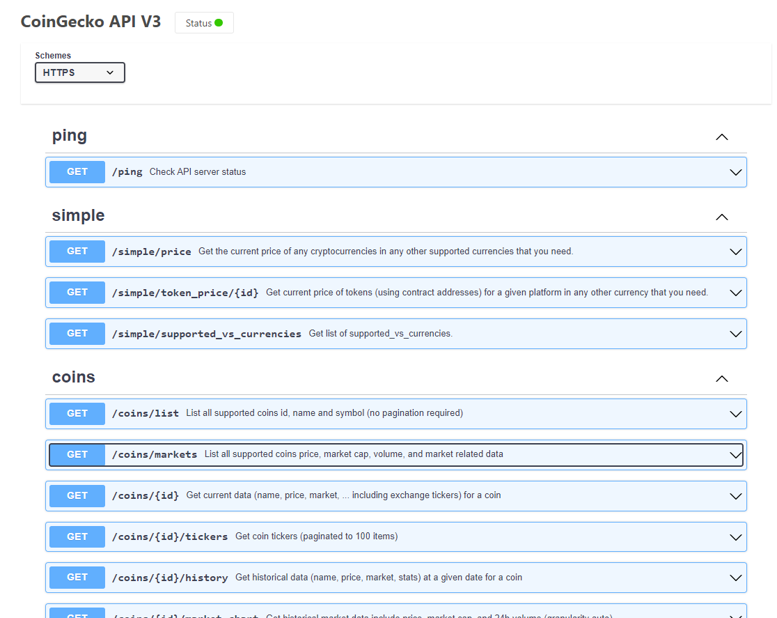

Fig 2.3.1

For this project we need /coins/market tool which returns value of coins on request.

/Coins/markets tool have various parameters that we can change such as currency what we want out price to be in, category of coins, how old data we want (1d, 7d, 30d)

**CHAPTER 3**

**IMPLEMENTATION AND RESULTS**

3.1 IMPLEMENATAION**:**

**Setting up the API –**

In order to get the required data, we set up the API first and that we do by changing sparkline, price change percentage and vs_currency in coingecko’s /coin/market tool. 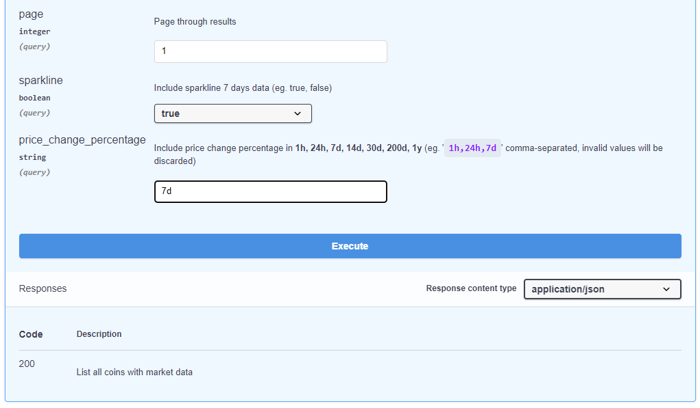

Fig 3.1.1

After we enter details and execute we get API’s request URL and Code details 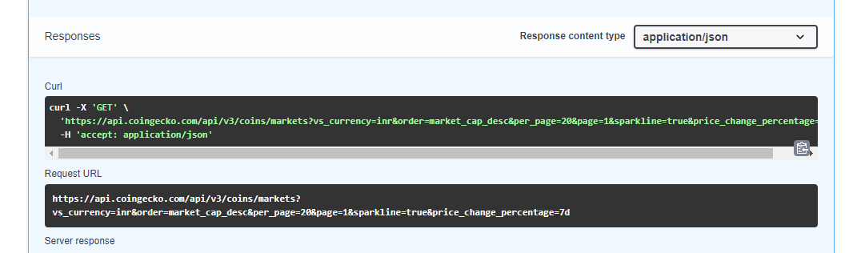 Fig 3.1.2

After getting the API request URL we include that URL in code and use the requested data in the application.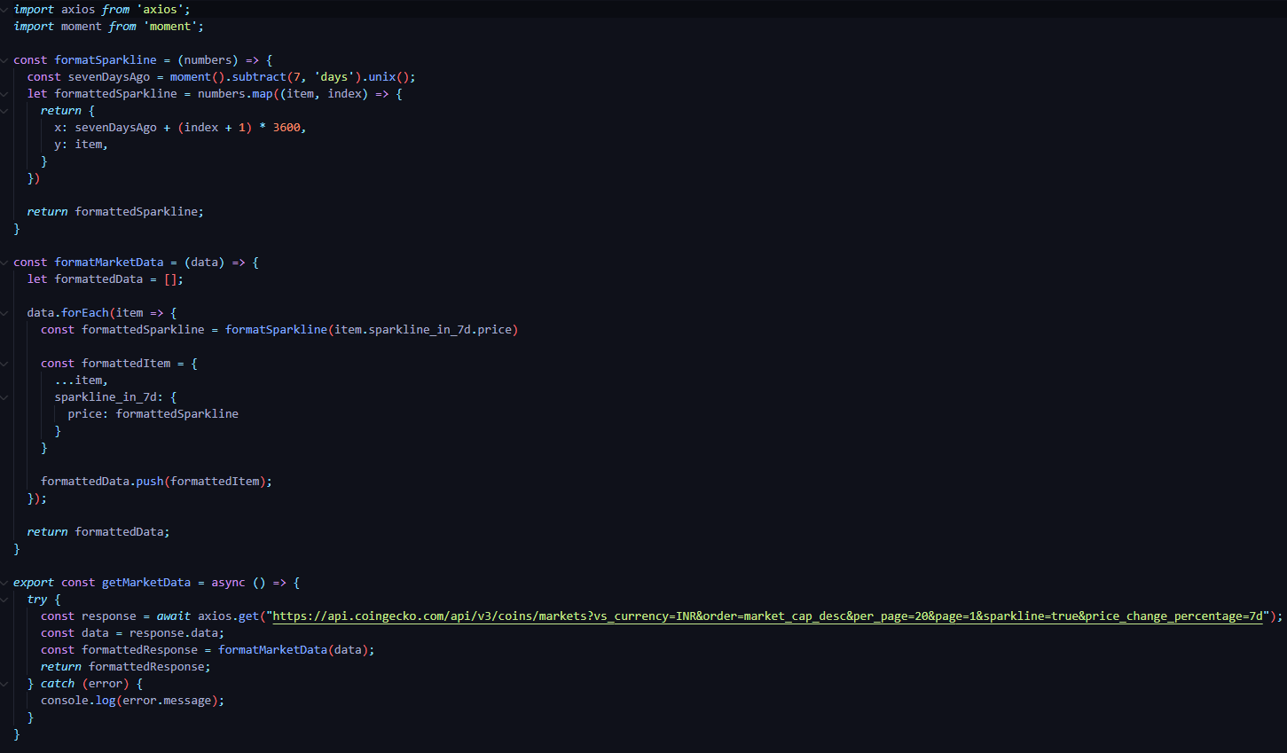Fig 3.1.3

After getting the required data we connect it with React Natives front end that we made to show live price changes in crypto prices and percentage change from last day. And we also make it have red coloe for negative change and green for positive change for easy identification of market changes.

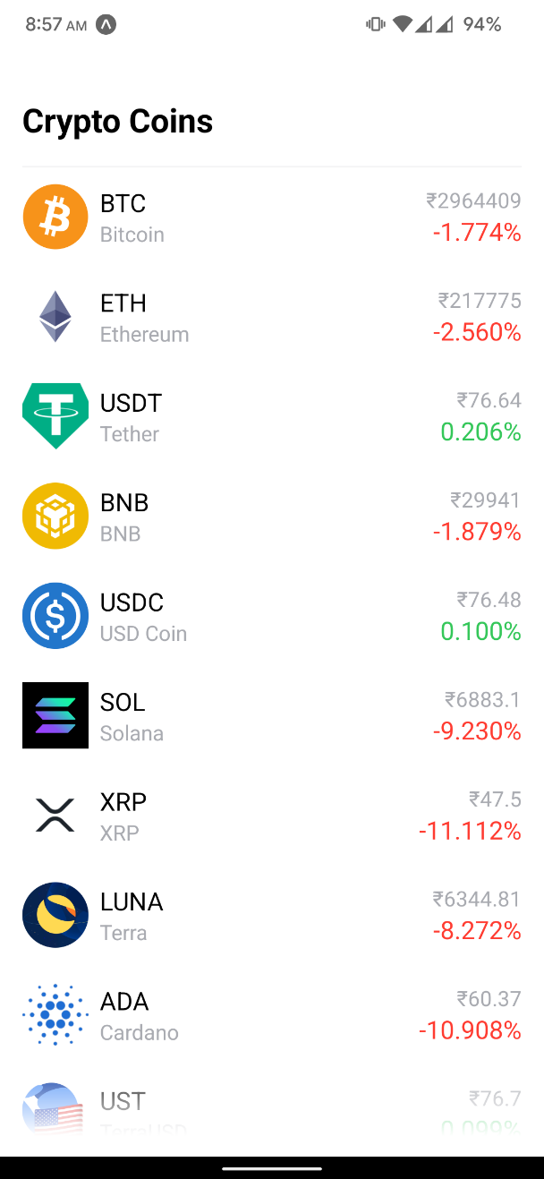

Fig 3.1.4

We then impliment the Bottom sheet libbrary in React Native for showing the price chart of cryptocurrency. In order to make those charts we are using ChartDot, ChartPath, ChartPathProvider, ChartYLabel from rainbow-me/animated-charts library.

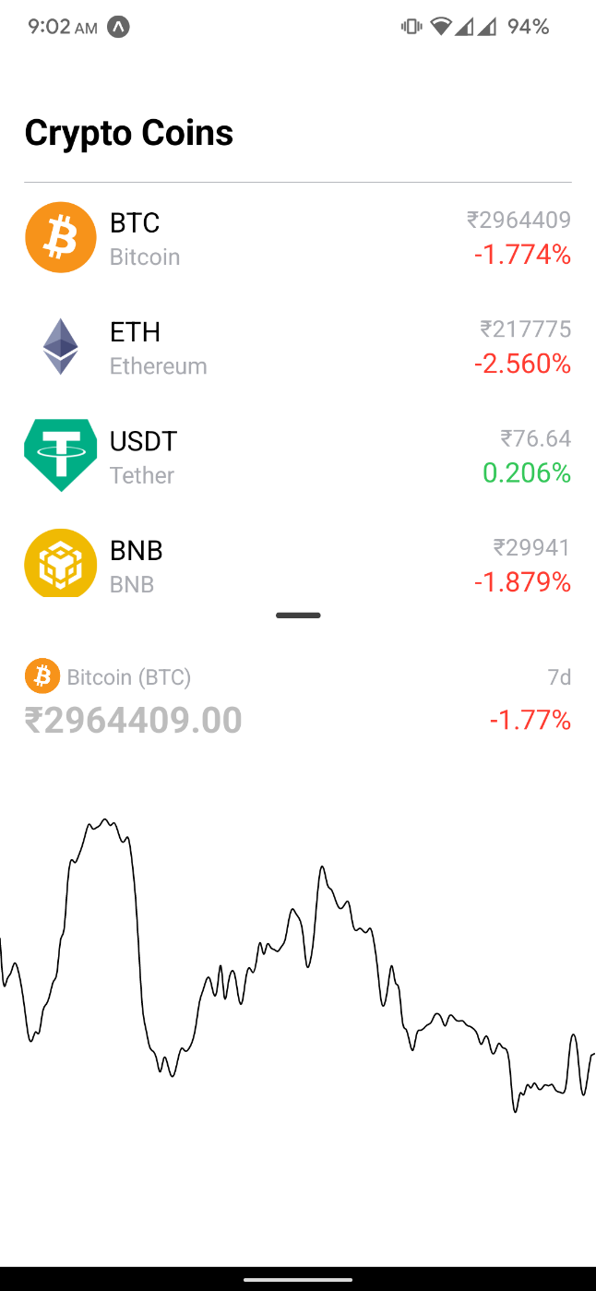

Fig 3.1.5

3.2 RESULTS**:**

After all this we get this result.

Live Prices of Cryptocurrencies with beautiful UI and the 7-day market chart which helps to understand the market conditions with past data.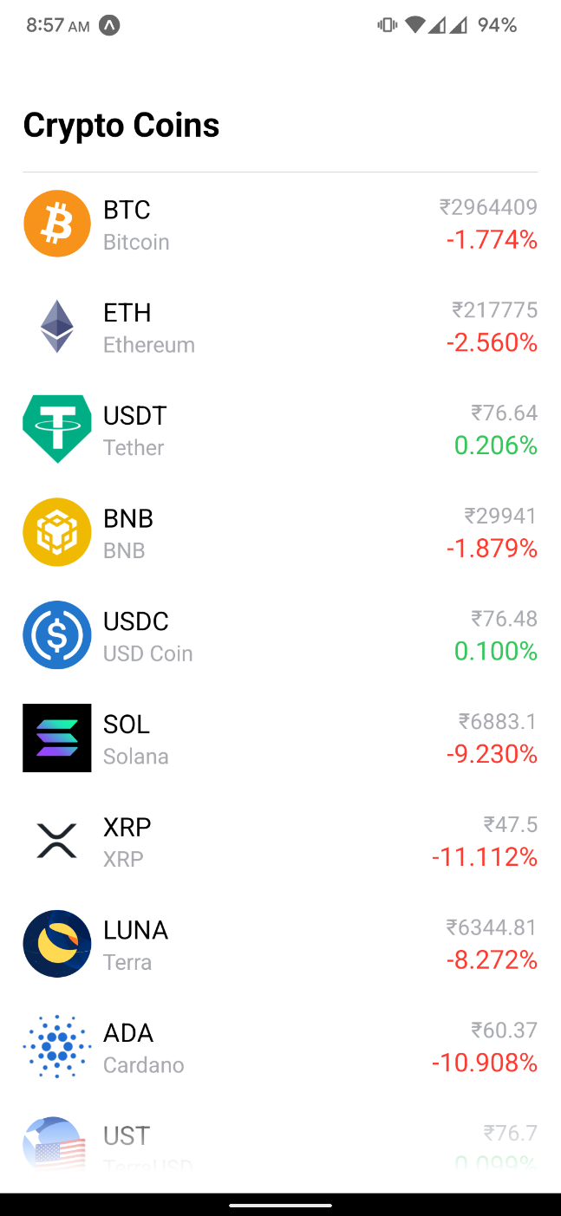 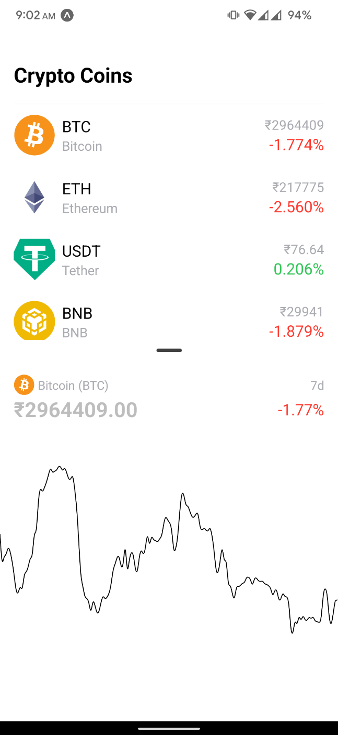

**CHAPTER 4**

# CONCLUSION AND FUTURE SCOPE

In Conclusion we crated the CryptoPriceTracker with live price monitoring and the charts for price monitoring.

Updating and maintenance of this application is really easy as it works with a reliable API.

This project has many future implementations such as adding variable market charts where user can choose between 1d, 7d, 30d charts of the selected cryptocurrency.

Also, the we can add different sections for different blockchain based technologies like NFT’s and its price monitoring.

We can also include some sections where users can chat and discus about different cryptocurrencies and current market conditions to form a community.

**CHAPTER 5**

# REFERENCES

**1 - React Native Documentation:**

[**https://reactnative.dev/**](https://reactnative.dev/)

**2 – CoinGecko API Documentation:**

[**https://www.coingecko.com/en/api/documentation**](https://www.coingecko.com/en/api/documentation)

**3 – forums to get help with problems and fixing bugs:**

[**https://stackoverflow.com/**](https://stackoverflow.com/)

**4 – Documentation of External libraries:**

[**https://www.npmjs.com/package/react-native-axios**](https://www.npmjs.com/package/react-native-axios)

[**https://www.npmjs.com/package/react-native-complete-flatlist**](https://www.npmjs.com/package/react-native-complete-flatlist)

[**https://www.npmjs.com/package/react-spring-bottom-sheet**](https://www.npmjs.com/package/react-spring-bottom-sheet)

[**https://github.com/rainbow-me/react-native-animated-charts**](https://github.com/rainbow-me/react-native-animated-charts)